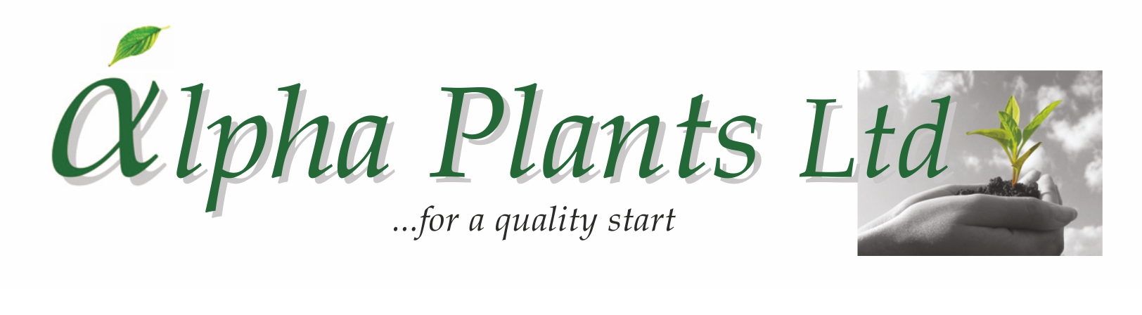
Herb Plug Availability

for Delivery

Wks 8 to 24, 2026

Company Name………………………………………………………………………………………………………

Address…………………………………………………………………………………………………………………...

………………………………………………………………………………………………………………………………………………………………………….

………………………………………………………………………………………………………………………………..

VAT Number…………………………………………... Purchase Order Number………………………………

Contact Name …………………………………………. Phone Number …………………………………….

Email Address ……………………………………………………………………………………………………………

Delivery Address (if Different) …………………………………………………………………………………………...

………………………………………………………………………………………………………………………………..

...................................................................................................................................................................................................

How to Order:

- Complete Company name and address details together with required delivery week.

- Complete the number of trays required by variety. Sold as 100 trays. Prices are quoted ex VAT, ex nursery and do not include transport. Transport will be quoted separately where required.

- Send your order back to us either by Email: enquiries@alphaplants.co.uk or by post to
Alpha Plants Ltd, Millview Nurseries, Fengate Road, West Pinchbeck, Spalding, Lincolnshire PE11 3NE.

4) Any questions, please call us on (01775) 640150 or Email: enquiries@alphaplants.co.uk

VAT Registration Number: 367 6849 36 Plant Passport Number: GB 32470

Common Name (A-Z) | Latin Name | Cell Tray Size | Price per Plant | DELIVERY WEEK(s) ………………..
 |  |  |  | Number of Trays required:
Alpine Strawberry | Fragaria vesca | 100 | 32p
Balm All Gold | Melissa officinalis ‘All Gold’ | 100 | 33p
Balm variegated | Melissa officinalis ‘Variegata’ | 100 | 33p
Chamomile Sweet | Chaemaemelum noblis | 100 | 32p
Coriander | Coriandrum sativum ‘Santos’ | 100 | 32p
Curry Common | Helichrysum angustifolia | 100 | 35p
Curry Dwarf | Helichrysum Italicum | 100 | 35p
Dill | Anethum graveolens ‘Diana’ | 100 | 32p
Fennel Bronze | Foeniculum vulgare ‘Purpureum’ | 100 | 34p
Fennel Common | Foeniculum vulgare | 100 | 34p
Five Leaf Ginseng | Gynostemma pentaphyllum *NEW* | 100 | 33p
French Tarragon | Artemisia dracunculus | 84 | 38p
Lemon Balm | Melissa officinalis (Cutting Raised) *NEW* | 100 | 33p
Marjoram Gold Tipped | Origanum vulgare 'Variegatum' | 100 | 33p
Mint After Eight | Mentha piperita f. citrata ‘After Eight’ | 100 | 33p
Mint Apple | Mentha suaveolens | 100 | 33p
Mint Lemon | Mentha piperita f. citrata ‘Lemon’ | 100 | 33p
Mint Moroccan | Mentha spicata ‘Moroccan’ | 100 | 33p
Mint No Mint, No Kiss ® | ‘Mintme’ *NEW* | 100 | 33p + 2p R
Mint No Mint, No Kiss ® | ‘Mint & Fruit’ *NEW* | 100 | 33p + 2p R
Mint No Mint, No Kiss ® | ‘Pepperminta’ *NEW* | 100 | 33p + 2p R
Mint Orange | Mentha piperita f. citrata ‘Orange’ | 100 | 33p
Mint Peppermint (Black) | Mentha x piperita | 100 | 33p
Mint Pineapple | Mentha suaveolens variegata | 100 | 33p
Mint Spearmint (Garden Mint) | Mentha spicata | 100 | 33p
Mint Strawberry | Mentha sp. ‘Strawberry’ | 100 | 33p
Mint Swiss | Mentha piperita f. citrata ‘Swiss’ | 100 | 33p
Mushroom Plant | Rungia klossii | 100 | 33p
Ocimum (Basil) | hybrida Blue (Available from Wk 12 onwards) | 84 | 38p
Oregano (Marjoram) | Origanum vulgare | 100 | 33p
Oregano Country Cream | Origanum vulgare ‘Variegata’ | 100 | 33p
Oregano Gold | Origanum vulgare ‘Gold Nugget’ | 100 | 33p
Oregano Hot ‘n’ Spicy | Origanum vulgare ‘Hot’ | 100 | 33p
Parsley Curled | Petroselinum crispum | 100 | 32p
Parsley French | Petroselinum crispum ‘Hortense’ | 100 | 32p
Parsley Giant Italian | Petroselinum neapolitanum | 100 | 32p
Rosemary Upright | Rosmarinus officinalis Britania (English Rosemary) | 84 | 38p
Rosemary Trailing | Rosemary officinalis Trailing | 84 | 38p
Rosemary ® | Rosemary officinalis ‘Sardinia’ (like Miss Jessops) | 84 | 38p + 4p R
Sage Golden | Salvia officinalis 'Icterina' | 100 | 35p
Sage Growers Choice | Salvia officinalis ‘Growers Choice’ | 100 | 35p
Sage Purple | Salvia officinalis 'Purpurea' | 100 | 35p
Sage Tricolour | Salvia officinalis 'Tricolour' | 100 | 35p
Sweetleaf | Stevia rebaudiana | 100 | 35p
Thyme Compact | Thymus vulgaris ‘Compact’ | 100 | 36p
Thyme Doone Valley | Thymus citriodorus 'Doone Valley' | 100 | 36p
Thyme Gold | Thymus citriodorus aureus | 100 | 36p
Thyme Lemon | Thymus citriodorus | 100 | 36p
Thyme Lemon variegated | Thymus citriodorus ‘Variegated’ | 100 | 36p
Thyme Orange | Thymus Orange | 100 | 36p
Thyme Silver Queen | Thymus citriodorus variegata 'Silver Queen' | 100 | 36p
Vietnamese Coriander | Polygonum odoratum | 100 | 35p
Winter Savory | Satureja montana | 100 | 35p

